# LockedMe Project submission By

# Ayush Maithani

Date of Submission: 04-september-2022

Source Code GitHub Link:

(Reference link for source code and project related files)

package com.company.lockers;

import java.io.File;

import java.io.FileWriter;

import java.util.LinkedList;

import java.util.Scanner;

public class LockedMe {

static final String projectpath = "C:\\Users\\dell\\eclipse-workspace\\LockersCompanyProject\\LockedMeFiles";

public static void main(String[] args)

{ Scanner obj = new Scanner(System.in);

int ch;

do

{

displayMenu();

System.out.println("Enter your choice:");

ch=Integer.parseInt(obj.nextLine());

switch(ch)

{ case 1: getAllFiles();

break;

case 2: createFiles();

break;

case 3: deleteFiles();

break;

case 4: searchFiles();

break;

case 5: System.exit(0);

break;

default:{ System.out.println("Invalid Option");}

break;

}

}

while(ch>0);}

public static void displayMenu()

{

System.out.println("***************************************************");

System.out.println("\tWelcome to Company Lockers - LockedMe.com");

System.out.println("\tDeveloper Name: Ayush Maithani");

System.out.println("***************************************************");

System.out.println("\t1. Display all the files");

System.out.println("\t2. Add files to existing directory");

System.out.println("\t3. Delete a file");

System.out.println("\t4. Search a file");

System.out.println("\t5. Exit");

System.out.println("***************************************************");

}

public static void getAllFiles()

{

File[] listOfFiles = new File(projectpath).listFiles();

//if the folder is empty

if(listOfFiles.length==0)

System.out.println("No files exist in the directory");

else

{

for(var l:listOfFiles)

{ System.out.println(l.getName()); }

}

}

public static void createFiles()

{

try

{ Scanner obj = new Scanner (System.in);

String fileName;

int linesCount;

System.out.println("Enter file name:");

fileName=obj.nextLine();

System.out.println("Enter how many lines you want to add in file");

linesCount=Integer.parseInt(obj.nextLine());

FileWriter fw = new FileWriter(projectpath+"\\"+fileName);

for(int i=1;i<=linesCount;i++)

{ System.out.println("Enter file content line:");

fw.write(obj.nextLine()+"\n");

}

System.out.println("File Created Successfully");

fw.close();

}

catch (Exception ex)

{ System.out.println("Some error occured.");

}

}

public static void deleteFiles()

{ Scanner obj = new Scanner(System.in);

try

{ String fileName;

System.out.println("Enter file name to be deleted:");

fileName=obj.nextLine();

File fl = new File(projectpath+"\\"+fileName);

if(fl.exists())

{ fl.delete();

System.out.println("File deleted successfully");

}

else

{ System.out.println("File do not exist");

}

}

catch(Exception Ex)

{ System.out.println("Some error occured"); }

}

public static void searchFiles()

{

Scanner obj = new Scanner(System.in);

try

{

LinkedList<String> fileNames = new LinkedList<String>();

String fileName;

System.out.println("Enter file name to be searched:");

fileName=obj.nextLine();

File[] listOfFiles = new File(projectpath).listFiles();

for (File l: listOfFiles)

{

fileNames.add(l.getName());

}

if (fileNames.contains(fileName))

{ System.out.println("file is available") }

else {

System.out.println("file is not available");

}

}

catch(Exception Ex)

{

}

}

}

Screen Shots of LockedMe Project

1. Welcome screen and files

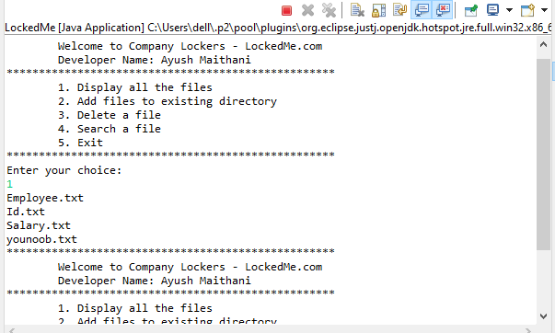

1. Adding new file i.e “check.txt”

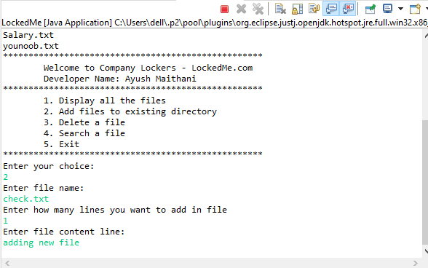

1. File added successfully

